Site Plan
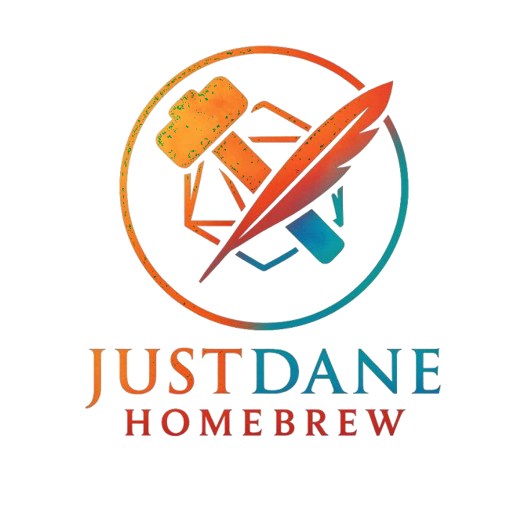
Logo

Intended Audience
My intended audience is Myself. I want a clean website that
contains all the DCD homebrew I’ve made and I want the ability to quickly update the lists. It should also be easily accessible for others looking for homebrew to navigate.

HEADER
(Logo) HOME, Monsters, Races, Items, Classes
Welcome Paragraph

Featured Content (The Newest of each section (I will Make sure to Mark it)
Footer (Contact Socials Copyright

Header (Same as Home Page)

Image of Thing (Item Monster Race)

Brief Description of Thing (Provided)

Tags (WIP) (OG)

Image of Thing (Item Monster Race)

Image of Thing (Item Monster Race)

Image of Thing (Item Monster Race) |  | Image of Thing (Item Monster Race) |  | Image of Thing (Item Monster Race)
Footer (Contact Socials Copyright

#7A0A0A

C41E1E

1A1A1A

#cccccc

FFFFFF
(White)

